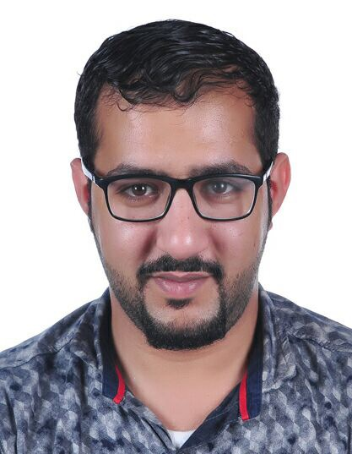

(ABBAS MANSOOR ALSAEED)
House: 230 Road: 3308 Block 633 Maameer
Mobile: | +97333948708 - +97339332729
Email: | Wojood_abbas@hotmail.com
CPR Number: | 940806282
Education and Qualifications
Commercial Secondary Certificate
(Al-Taawon Secondary Boys School – 2013)
Associated Experience
May 2010 - Present | Alsaeed house for communication & Real state
- Managing budgets.
- Evaluating repairing methods.
- Monitoring sales operation.
- Submitting monthly reports to the principals
- Process quotations from suppliers and deal with clients.
I gained and enhanced many skills during the past year including high multitasking ability, bargaining power with clients, ability to work well under pressure, good time management, and attentive to the small details.

Programs & Participations
A9EEL
- Leadership course in the Institute for Student Leaders sponsored by the ministry of education.
- A9EEL: 6 students were selected from each school through the ministry to participate in the competition and for learning leadership among other subjects for 5 weeks.
Key I.T. Skills
- Microsoft Office.
- Mobile programing softwares.

Other / Personal Details
Interests:

- Reading about programs and technology.
- Learning new things and updates about technology.
- Listening to classical music.

REFERENCES ARE AVAILABLE ON REQUEST

